Messengers of Love
Sponsorship Levels and Benefits

Name: |  | Email:
Company: |  | Phone:
Address: |  | City, State, Zip:

Please mark a sponsorship level below and fill out the payment form on the following page:

☐Love - $5000 and up:
- One VIP “Love” table of 10 at the Christmas Charity Gala
- One page ad in Messengers of Love bi-annual year-end report
- Announcement of sponsorship on the radio and TV
- Announcement of sponsorship at Messengers of Love Christmas Charity Gala
- Logo on our website with link to your website for one year
- Company listed in the gala program book
- Logo on 2 large screens at the Christmas Charity Gala
- Recognition in all press releases and marketing materials for all MOL events in 2015

☐Compassion - $2500:
- One VIP “Compassion” table of 10 at the Christmas Charity Gala
- One half page ad in Messengers of Love bi-annual year-end report
- Announcement of sponsorship on the radio and TV
- Announcement at Messengers of Love Christmas Charity Gala
- Logo on our website with link to your website for one year
- Company listed in the gala program book
- Logo on 2 large screens at the Christmas Charity Gala

☐Kindness - $1500:
- 6 VIP seats at the Christmas Charity Gala
- Announcement at Messengers of Love Christmas Charity Gala
- Logo on our website with link to your website for six months
- Company listed in the gala program book

☐Goodness - $1000:
- 4 VIP seats at the Christmas Charity Gala
- Announcement at Messengers of Love Christmas Charity Gala
- Company listed in the gala program book

☐Gentleness - $500:
- 2 VIP seats at the Christmas Charity Gala

☐Individual - $100:
- A regular seat at the Christmas Charity Gala *
* Please indicate the number of tickets you wish to purchase. Tickets

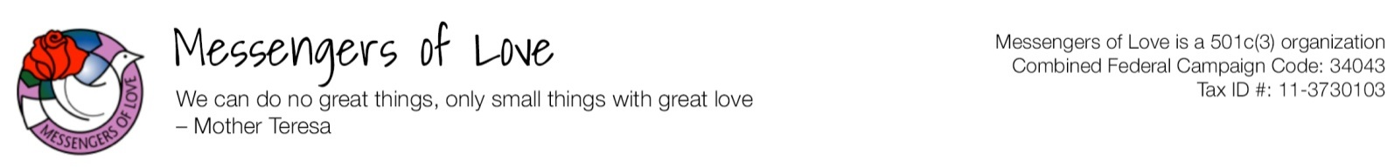
DONATION AND SPONSORSHIP FORM

Please email form to: messengersoflove@gmail.com
Or mail to: Messengers of Love P.O. Box 590936, Houston TX, 77259

Note that all donations above dinner cost are tax deductible as MOL is a 501c(3) organization.
THANK YOU FOR YOUR GENEROSITY.

I am sponsoring the MOL event at the level of (please mark one):
☐Love ☐Compassion ☐Kindness ☐Goodness ☐Gentleness ☐Individual
The number of guests attending including myself will be: Click here to enter text.
In the amount of $ Click here to enter text.

☐Donations:
I am unable to attend the gala but would like to make a donation in the amount of $ Click here to enter text.

☐Yearly sponsorship at $150 per child:
I am unable to attend the gala but would like to sponsor a child/children in the yearly amount of:

☐$150 ☐ $300 ☐ $450 ☐ $1,500 ☐ Other amount for $Click here to enter text.

Payment Method

☐My check is enclosed in the amount of $ Click here to enter text. Check# Click here to enter text.
Make check payable to “Messengers of Love” and send to the address at the bottom of this form.

* On line donation, visit: www.messengersoflove.com/donation

Please charge my: | ☐AMEX | ☐DISCOVER | ☐MASTERCARD | ☐ VISA

Card number: Click here to enter text. | Expiration Date: Click here to enter text.

CVV on back: Click here to enter text. | Amount: $ Click here to enter text.

Name on the card: Click here to enter text. | Phone Number: Click here to enter text.

Billing address: Click here to enter text.

City: Click here to enter text. | State: Click here to enter text. | Zip: Click here to enter text.

Date: Click here to enter text.

